Acidity of α-hydrogen

* Acidic because oxygen pulls some of the electron density out of the C-H bonds (through induction) → weaken them → easy to deprotonate the α-carbon, esp in basic solutions

1. Electron withdrawing groups like oxygen **stabilize** organic anions (resonance)
2. Electron-donating groups like alkyl groups **destabilize** organic anions
   * That is why α-hydrogens of ketones tend to slightly less acidic than those of aldehydes due to the electron donating properties of the additional alkyl group in a ketone

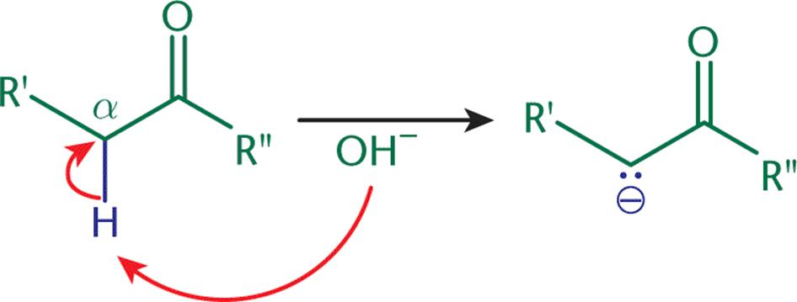

(Deprotonation of an α-Carbon, forming a carbanion)

Steric Hindrance

* **Ketones are less likely to react with nucleophiles than aldehydes** because the extra alkyl group
  + Destabilizes the carbanion (mentioned above)
  + Increases steric hindrance → crowds the transition step and increases energy

Keto-Enol Tautomerization

* Enol = ene + ol (C=C double bond + alcohol)
* Tautomerization is NOT resonance
* Keto form is more thermodynamically favored over the enol form

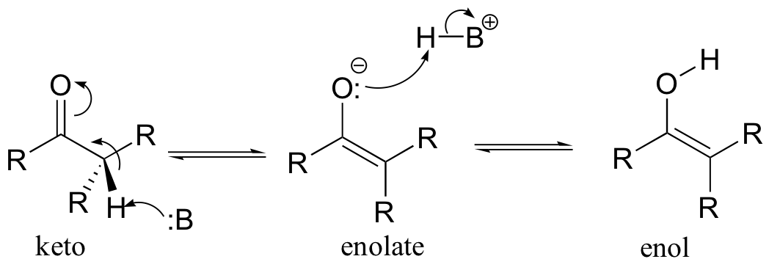

* Michael Addition
  + Carbanion attacks an α,β-unsaturated carbonyl compound (step b)

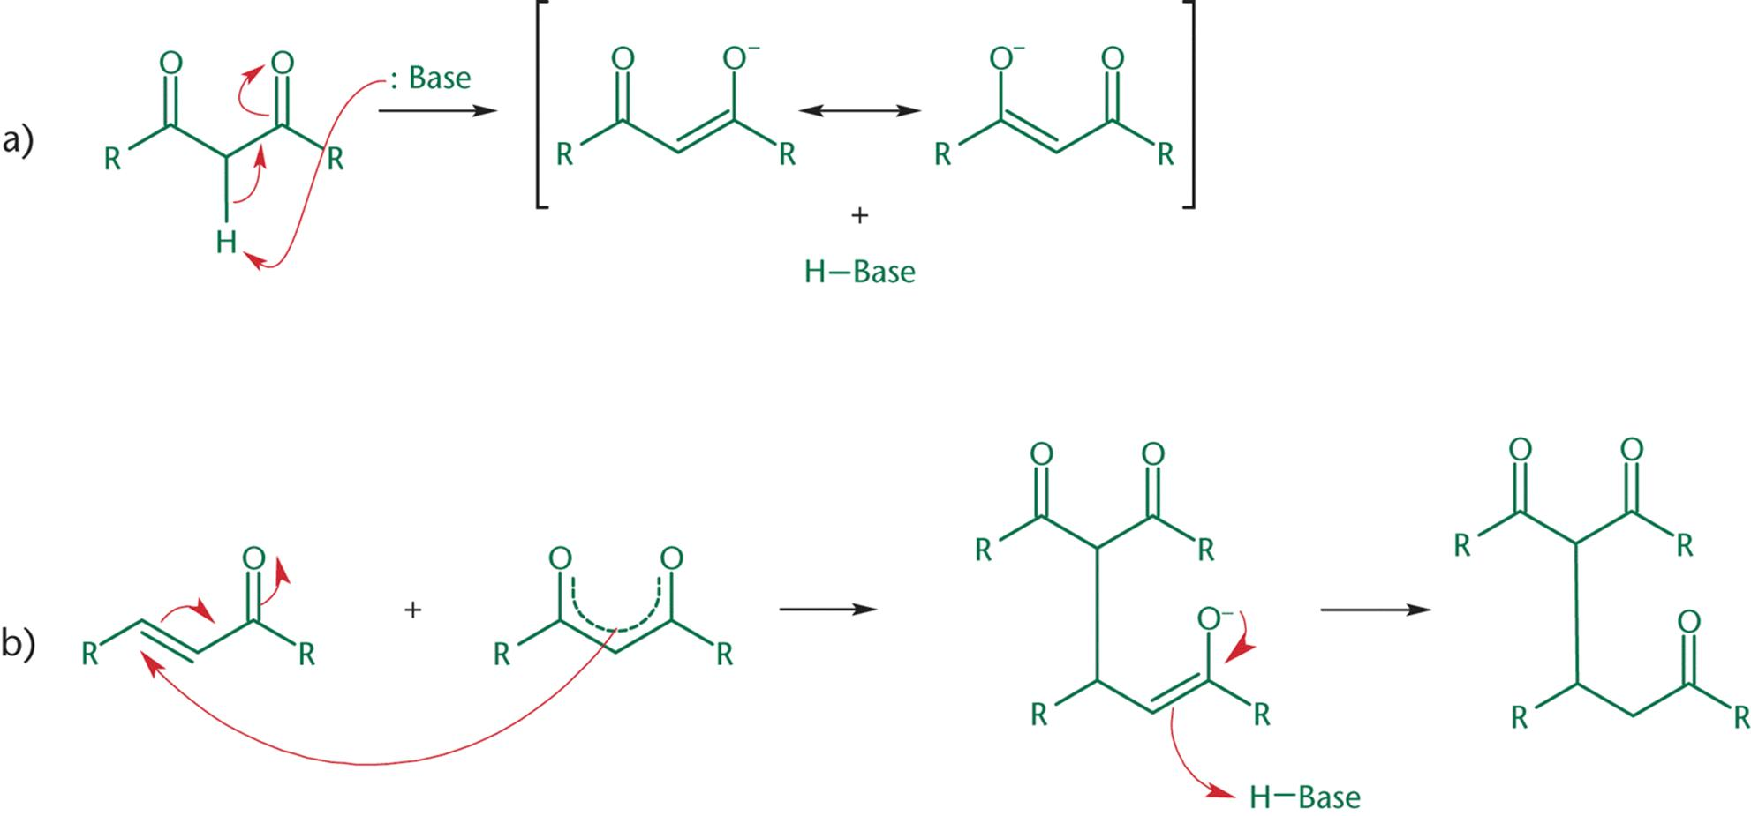

1. The base deprotonates the α-carbon, making it a good nucleophile
2. The carbanion attacks the double bond, resulting in a Michael addition

Kinetic and Thermodynamic Enolates

* The kinetic enolate forms more quickly (because less hindrance from H), but is less stable than the thermodynamic enolate (because the latter is more substituted)

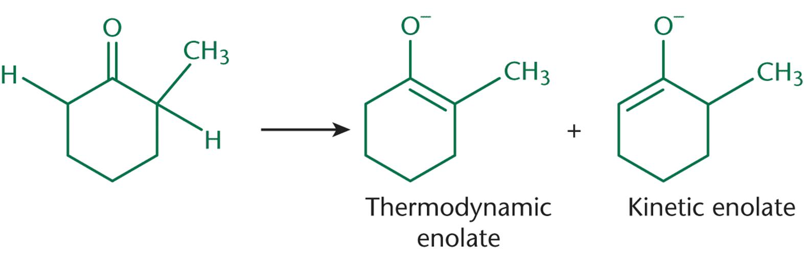

Enamines

* Imine form is more thermodynamically favoured over the enamine form

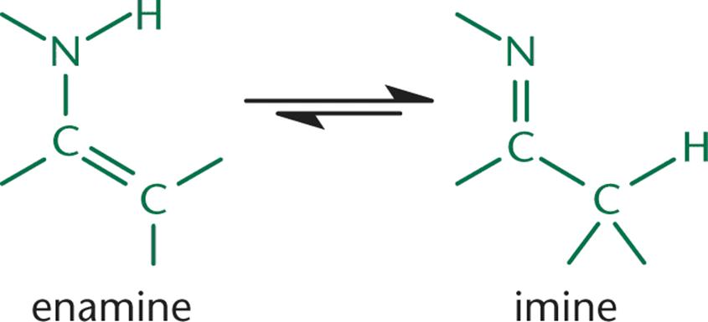

Aldol Condensation

* Aldol = aldehyde + alcohol
* E.g. acetaldehyde treated with catalytic amount of base

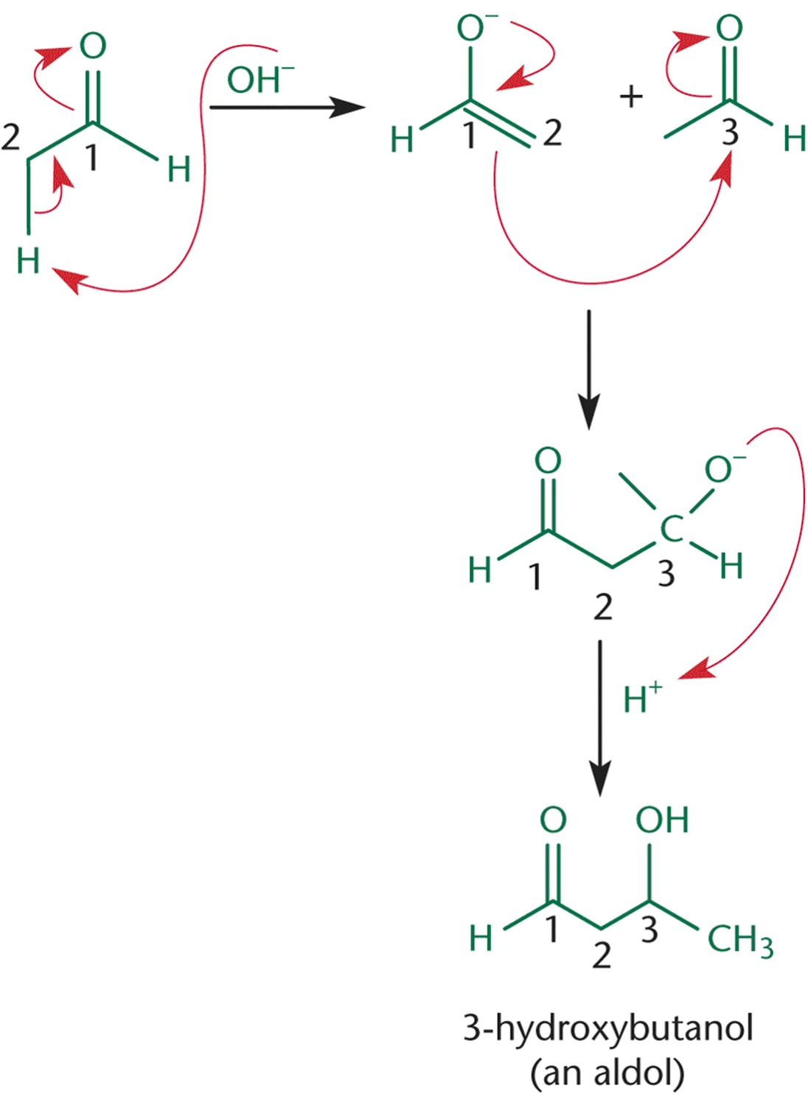

(Step 1: an enolate ion (Nu-) is formed, which then attacks the carbonyl carbon of the keto form (E+), forming an aldol)

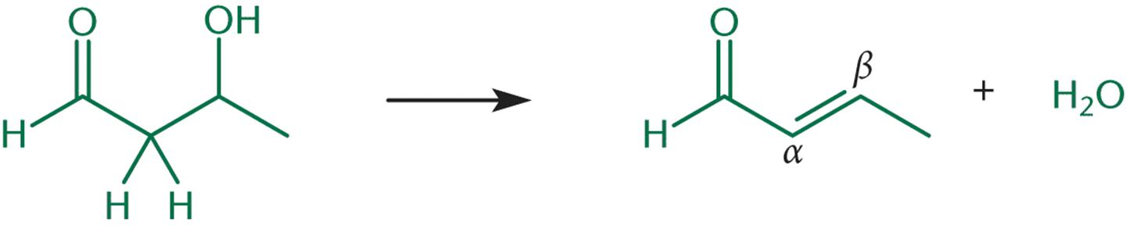

(Step 2: Dehydration occurs via E1 or E2 mechanism)

Retro-Aldol Reaction

* Reverse of an aldol reaction
* Favoured by the addition of base and heat
* A bond between the α- and β-carbons of a carbonyl is broken

